General Purpose Boundary
Element Software Technology Release Guide

Version 6.0

October 1999

Boundary Element Software Technology Corporation
P.O. Box 310
Getzville, New York 14068-0310, USA
Telephone: (716) 639-1920 Fax: (716) 639-1919 Email: support@gpbest.com

PROPRIETARY DOCUMENT NOTIFICATION

Boundary Element Software Technology Corporation (called Best Corporation, hereafter) reserves the right to make changes in specifications and other information contained in this document without prior notice.

Although due care has been taken to present accurate information, Best Corporation DISCLAIMS ALL WARRANTIES WITH RESPECT TO THE CONTENTS OF THIS DOCUMENT (INCLUDING WITHOUT LIMITATION WARRANTIES OF MERCHANTABILITY AND FITNESS FOR A PARTICULAR PURPOSE) EITHER EXPRESSED OR IMPLIED. Best Corporation SHALL NOT BE LIABLE FOR DAMAGES RESULTING FROM ANY ERROR CONTAINED HEREIN, INCLUDING, BUT NOT LIMITED TO, FOR ANY SPECIAL, INCIDENTAL OR CONSEQUENTIAL DAMAGES ARISING OUT OF, OR IN CONNECTION WITH, THE USE OF THIS DOCUMENT.

GPBEST™ is a trademark of Best Corporation.
BESTVIEW™ is a trademark of Best Corporation.

This software product and its documentation set are copyrighted and all rights are reserved by Best Corporation. Usage of this product is only allowed under the terms set forth in the GPBEST License Agreement. Any reproduction or distribution of this document, in whole or in part, without the prior written consent of Best Corporation is prohibited.

RESTRICTED RIGHTS NOTICE

If this software is furnished to a U.S. Department of Defense agency, the following applies:

RESTRICTED RIGHTS LEGEND

``Use, duplication, or disclosure by the Government is subject to restrictions as set forth in subdivision(b)(3)(ii) of the Rights in Technical Data and Computer Software clause at DOD FAR SUP 52.227-7013. Best Corporation,P.O. Box 310, Getzville, NY 14068-0310.''

If this software is furnished to the National Aeronautics and Space Administration, the following applies:

RESTRICTED RIGHTS LEGEND

This computer software is submitted with ``restricted rights.'' Use, duplication or disclosure is subject to the restrictions as set forth in NASA FAR SUP 18-52.227-79 (April 1985) ``Commercial Computer Software-Restricted Rights (April 1985).'' Best Corporation, P.O. Box 310, Getzville, NY 14068-0310. If the contract contains the Clause at 18-52.227-74 ``Rights in Data General'' then the ``Alternate III'' clause applies.

Copyright ©1991,©1993 and ©1995-1999 Boundary Element Software Technology Corporation
All rights reserved

If you would like to order more copies of this User Manual, please contact the Documentation Coordinator at Best Corporation. U.S.A. orders: All orders must be accompanied by a check or purchase order. Your order will be sent prepaid via UPS or fourth class mail and the shipping charges will be added to the invoice. F.O.B. will be the shipping point. Terms are net amount due within 30 days. Outside U.S.A. orders: Please contact Best Corporation for a quotation.

Part Number 980010

CONTENTS

PROPRIETARY DOCUMENT NOTIFICATION 2
1 Installing GPBEST 3
2 Installing the GPBEST Distribution on WINNT 7
3 Version 6.0 Documentation and Online Manuals 8
4 GPBEST Information Sources 15
4.1 Corporate Web Site 15
4.2 GPBEST Hard Copy Manuals 16
4.3 GPBEST On-line Manuals 17

1 Installing GPBEST

Please read all instructions carefully. It is recommended that the system administrator perform this installation and refer any questions or problems to Boundary Element Software Technology Corporation at email: support@gpbest.com, telephone: (716) 639-1920 or fax: (716) 639-1919. There are currently three methods for receiving the GPBEST distribution:

- 90 M DDS Data Cartridge – Instruction for installing GPBEST from this media are located in the GPBEST USER’S MANUAL Volume I, Version 6.0, October 1999, Section 1.2 GPBEST INSTALLATION INSTRUCTIONS.
- CDROM – Instructions for installing GPBEST from this media are located in this GPBEST Release Guide, Version 6.0, October 1999, Section 1.1 Installing GPBEST.
- Website Download – Instructions for installing GPBEST from this media are located in the Getting Started section of the GPBEST website.

The GPBEST Release CDROM has several different options for installation to give the user more flexibility in loading only the portions of GPBEST that are used and licensed. The following listing shows the current GPBEST modules and what they contain:

- Core GPBEST Module
  - Architecture dependent best-t24:
GPBEST executable for ALL analysis types Standard analyses contained in best-s24 are also contained in best-t24. However, it is recommended that best-s24 be used for standard analysis since best-s24 requires less computer resources to execute. best-t24 should be used for all other analyses not contained in best-s24. These are periodic acoustics, structural acoustics, forced vibration and plasticity analysis. (24,000 d.o.f.)
  - Architecture dependent best-s24:
GPBEST (standard) executable for elastic, thermoelastic distortion, heat conduction, diffusion, consolidation, fracture, contact and gap, free vibration and acoustic eigenfrequency analysis. (24,000 d.o.f.)
  - Architecture dependent best-t80:
GPBEST (total) executable (80,000 d.o.f.). For smaller problems use best-t24 for best efficiency.
  - Architecture dependent best-s80:
GPBEST (standard) executable (80,000 d.o.f.). For smaller problems use best-s24 for best efficiency.
- Architecture independent README :
Short description of GPBEST version contents.

- Architecture independent mangpb :
Unix shell script, written for the Bourne shell, for starting the Online Manual Viewer.
- Architecture independent gpbest.pdf :
Online Manual file for GPBEST User’s Manual Volume I.
- Architecture independent bestview.pdf :
Online Manual file for GPBEST User’s Manual Volume II.
- Architecture independent tutorial.pdf :
Online Manual file for GPBEST Elastic Tutorial Manual.
- GPBEST example file directory :
Contains large and small GPBEST example file data sets and results for a large number of problems. These problems can be used for reference in producing GPBEST data sets. NOTE: The GPBEST example files are delivered in compressed format using gzip. An architecture dependent gzip executable is provided in the GPBEST bin directory for all platforms to uncompress these files. Usage of the gzip executable can be viewed by typing “gzip - -help” on the command line.

- Core GPBEST-DCE Module
  - Architecture dependent best-dce :
Main GPBEST-DCE executable for distributed computing environment analyses.
  - Architecture dependent best-slave :
Slave GPBEST-DCE executable for distributed computing environment analyses.
  - Architecture dependent best-gs :
GPBEST-DCE group functions and communication executable for distributed computing environment analyses.
  - dce-arch :
Executable unix shell script sets the DCE_ARCH environment variable to the DCE architecture abbreviation of the executing host for distributed computing environment analyses.
  - dce-d :
Executable shell script which determines the executing hosts architecture for the networking daemon and communication executable.
  - dce-cshrc :
This text file must be customized if GPBEST-DCE installation does not reside in /usr/local/gpbest.
- GPBEST-DCE example file directory :
Contains large and small GPBEST-DCE example file data sets and results for a large number of problems. These problems can be used for reference in producing GPBEST-DCE data sets.

- Core BESTVIEW module
  - Architecture dependent bestview :
BESTVIEW (Boundary Element Software Technology Viewer) is a graphic pre- and post-processor for generation and viewing of structural models as well as for preparation of input data for subsequent analysis through GPBEST.
  - COLORBAR :
(non-executable) Colorbar for BESTVIEW. BESTVIEW has a unique coloring scheme. If the user would like to use the traditional colors (red, orange, yellow, green, blue), then include the appropriate COLORBAR in your working directory and select it from within BESTVIEW (see the BESTVIEW manual for details).

  - BestviewFonts.inc :
(non executable) Fonts used in BESTVIEW. This file lists the fonts used by the BESTVIEW software for displaying the menu and other messages. This file should be placed in the same directory as bestview.

- Core TRANSLATOR module
  - Architecture dependent prebest :
GPBEST translator. Translates PATRAN neutral files, I-DEAS universal files, HYPERMESH ASCII neutral files, and FEMAP ASCII neutral files to GPBEST input data files.
  - Architecture dependent postbest :
GPBEST translator. Translates GPBEST neutral file (NEUTRAL.OUT) created during GPBEST execution to a PATRAN neutral file or an I-DEAS universal file or a HYPERMESH ASCII neutral file or a FEMAP ASCII neutral file for post processing of GPBEST results.
  - Architecture dependent iges :
iges executable. iges executable module is used by the BESTVIEW software to import IGES files.
- GPBEST translator templates :
The following files are used for GPBEST translator integration with other programs gpb_acou_nod.res_tmpl, gpbest_dis.res_tmpl, gpbest_els.res_tmpl, gpbest_nod.res_tmpl and gpbest_not.res_tmpl.

2 Installing the GPBEST Distribution on WINNT

After downloading the GPBEST program files distribution, decide where you will install GPBEST on your computer. The installation directory must have approximately 25 megabyte of disk storage available for installation. Using PKZIP or WinZip extract the standard distribution zip file. For example,

(Installation directory) = C:\software

After extracting the distribution zip file the installation directory contains:
C:\software\gpbest GPBEST program file directory
C:\software\gpbest\Readme.txt Important information about GPBEST
C:\software\gpbest\bin\WINNT Executable directory for WINNT
C:\software\gpbest\manuals Online manuals for GPBEST
C:\software\gpbest\templates GPBEST Patran templates

The program files are now installed.

For the GPBEST1000 DOF version:

The path for the executable directory must be included into the system path environment variable. This can be done in two ways,
  - Modify the autoexec.bat file located on the boot partition of the system to include the following line set PATH=(Installation directory)\gpbest\bin\WINNT
  - In Windows NT/2000 use the following menu commands Start/Settings/Control Panel/System/Environment select the Path variable and add the following to this variable (Installation directory)\gpbest\bin\WINNT

For the GPBEST 3000 and 6000 DOF versions:

The path for the executable directory must be included into the system path environment variable. This can be done in two ways,
- Modify the autoexec.bat file located on the boot partition of the system to include the following line set PATH=(Installation directory)\gpbest\bin\WINNT
- In Windows NT/2000 use the following menu commands Start/Settings/Control Panel/System/Environment select the Path variable and add the following to this variable (Installation directory)\gpbest\bin\WINNT

A GPBEST password file must be obtained to execute the 3000 and 6000 DOF versions. A program, “ntlicinfo.exe”, is provided in the gpbest\bin\WINNT directory to extract the required license information from your system. Please execute this program in the gpbest\bin\WINNT directory to produce the “password_info” file. Email the “password_info” file as an attachment to support@gpbest.com and a password file will be emailed back to you. The environment variable “GPBEST_PASSWORD_FILE” needs to be added to your system. This can be done in two ways,
a. Modify the autoexec.bat file located on the boot partition of the system to include the following line set GPBEST_PASSWORD_FILE=(Installation directory)\gpbest\bin\WINNT\password
b. In Windows NT/2000 use the following menu commands Start/Settings/Control Panel/System/Environment define a new Variable in the form field as “GPBEST_PASSWORD_FILE” and define a new Value in the form field as (Installation directory)\gpbest\bin\WINNT\password

NOTE: This assumes that the user places the GPBEST password file in the (Installation directory)\gpbest\bin\WINNT\password directory and names it password.

3 Version 6.0 Documentation and Online Manuals

The current GPBEST Release 6.0 has been shipped with online manuals and hard copy manuals. There is no difference between the hard copy and online version of the manuals. But there are some significant advantages in using the online versions. The following pages will give you an overview of what capabilities are now available in the online manuals and how to navigate through the manuals efficiently. Major points to keep in mind are:

- The online manuals are completely text searchable.
- Table of Contents bookmarks are supplied to navigate easily through the Chapters and Sections.
- Keyword bookmarks are supplied to easily find GPBEST input keywords.
- Thumbnails are supplied to navigate quickly through manuals.

To view the online manuals use the latest version of Adobe Acrobat Reader.

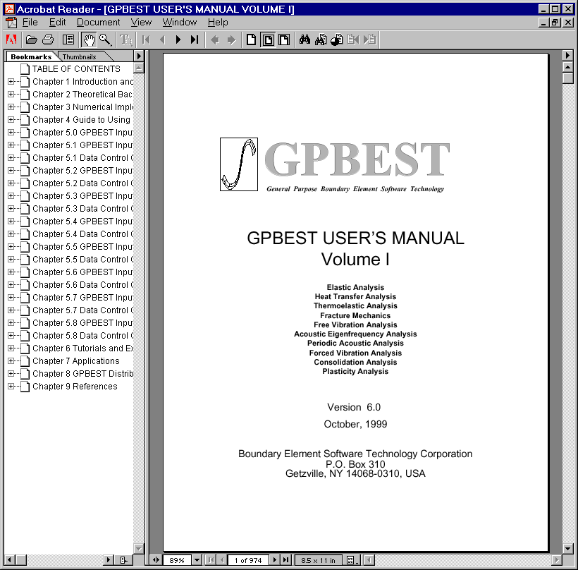

As you can see, the bookmarks are located on the left and a full-page view on the right. This is the default display for all of the GPBEST online manuals. By clicking on the Table of Contents bookmark with the left mouse button the GPBEST User’s Manual Volume I page appears. This page, like many other pages in the manual, is also hyperlinked to all the Chapters and Sections of the manual. Within the viewer, an open hand represents the default cursor or pointer. As you move the hand around the page, it will change to a pointed finger over certain areas of text. This change in the hand indicates a hyperlink. If the pointed finger is clicked, you are transported to the hyperlinks destination. As in the following example, if you click on the text “1.0” on the Table of Contents page, you will be moved to the “1.0 Introduction and Installation” page.

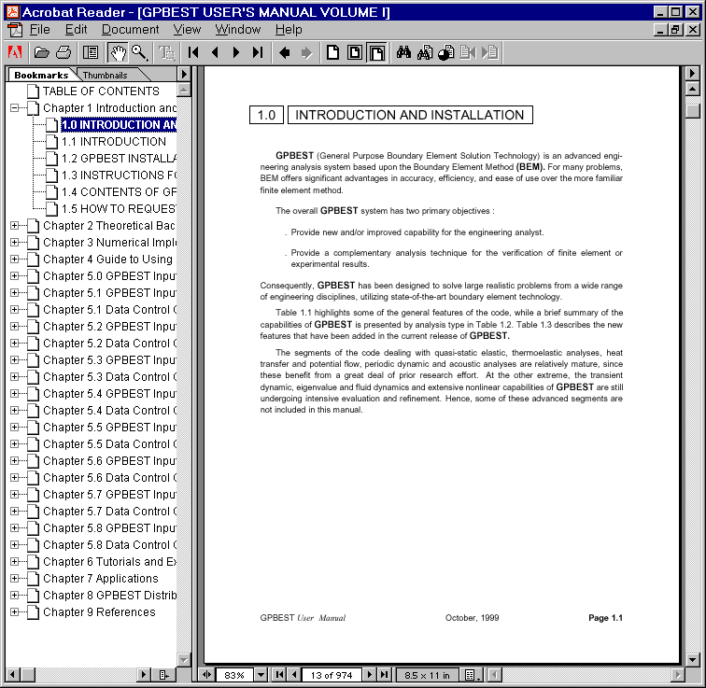
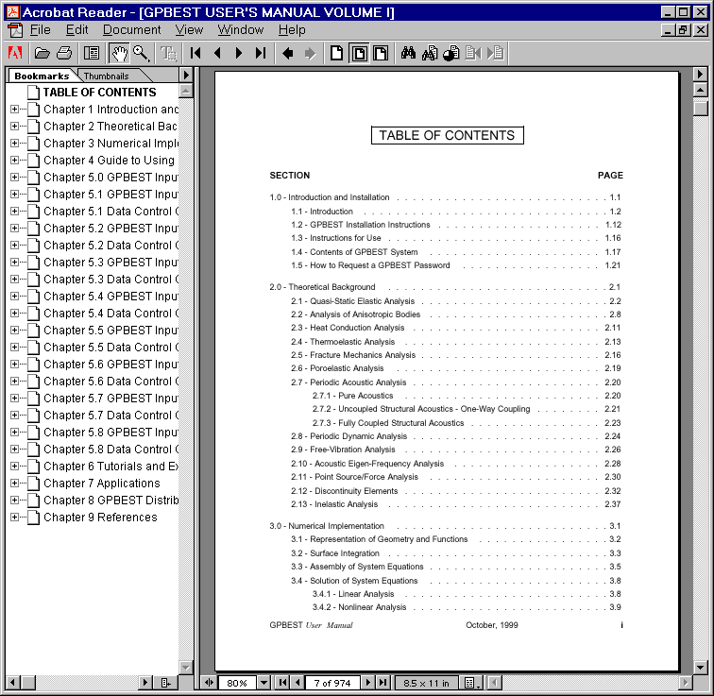

To return to the page where you clicked on the hyperlink, use the right mouse button and select “Go Back”. Selecting the bar between the bookmarks and page view can expand the bookmark window. Use the left mouse button to select the bar and drag it to the right. Expanding the bookmark outline for Chapter 5.1, we can see several helpful links for the Chapters, Sections and keywords of GPBEST input.

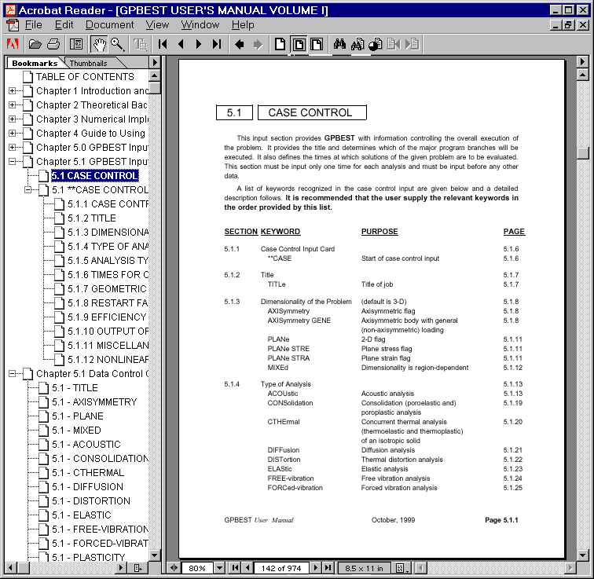
Another very useful function now available for all of the GPBEST manuals is full text searching. At the top menu bar there is an icon of binoculars. Left click on this icon and type in a search phrase. For an example, we will look for all places where the text “TIMEs-output” occurs. After executing this search several times, we find the text we were searching for. Of course, to find this keyword page, we could have just clicked on the appropriate bookmark.

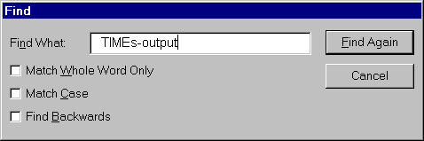
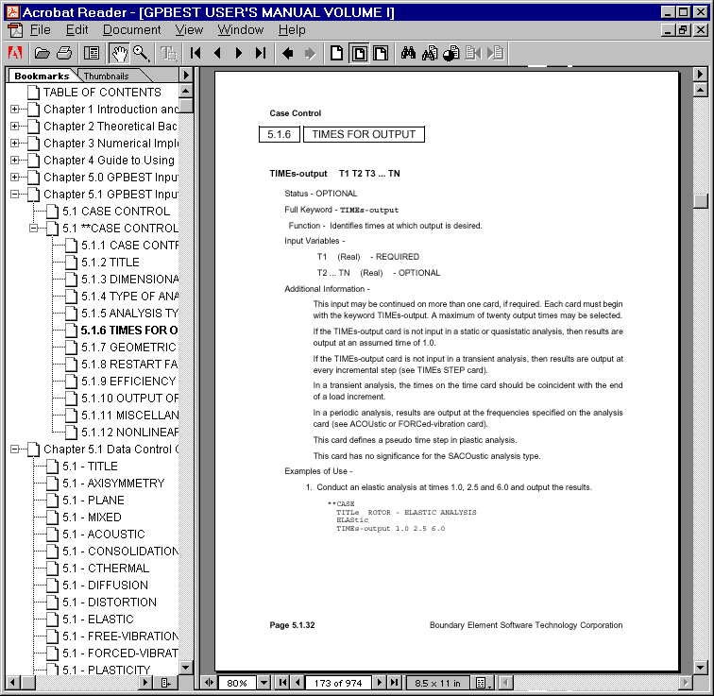
If you wish to go to a specific page number, change the page view or backtrack through the pages you have seen, these functions and many more are located in the pull down menus at the top of the viewer under “View”. One final view is the thumbnails. These are particularly helpful to the user who is very familiar with the GPBEST Manuals and wants to flip through the pages as though they were using a hard copy manual. Clicking the third icon from the left at the top of the viewer removes the bookmark view and shows the thumbnail view. Expanding this view, the user can look at many pages and find the appropriate section in the manual by sight rather than page or section number (this makes it easy to find many of the graphics in the GPBEST manuals).

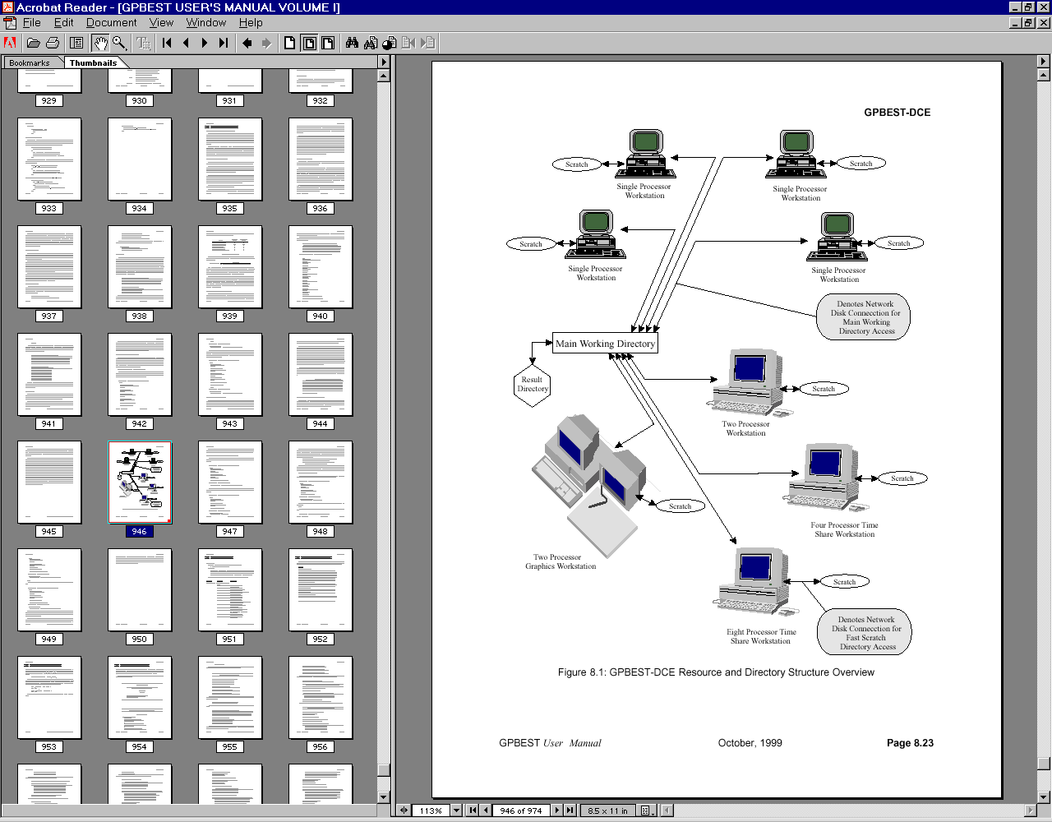

Many other page views are available to search and view all of the GPBEST manuals.

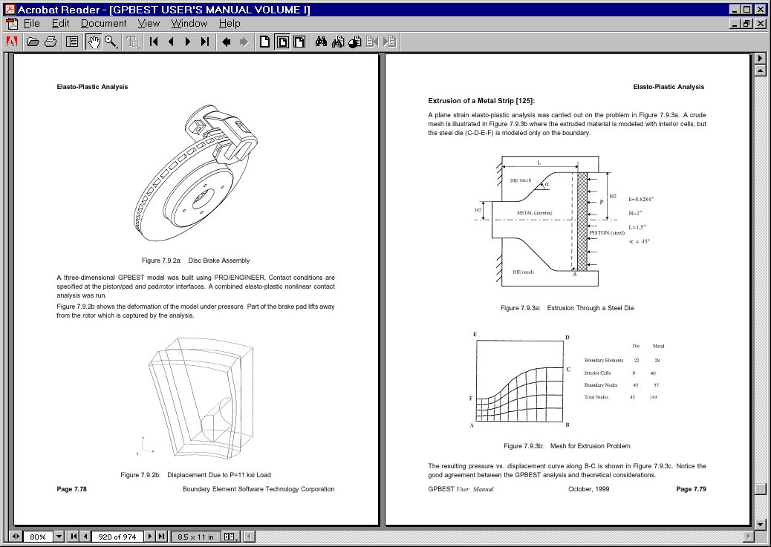

The startup screen for the other GPBEST manuals.

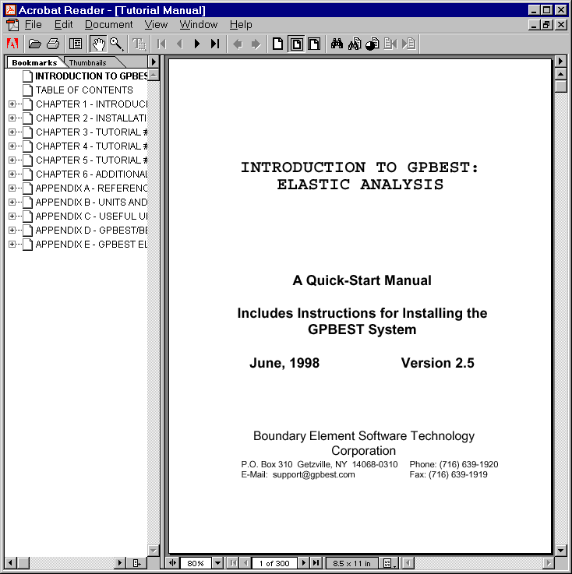
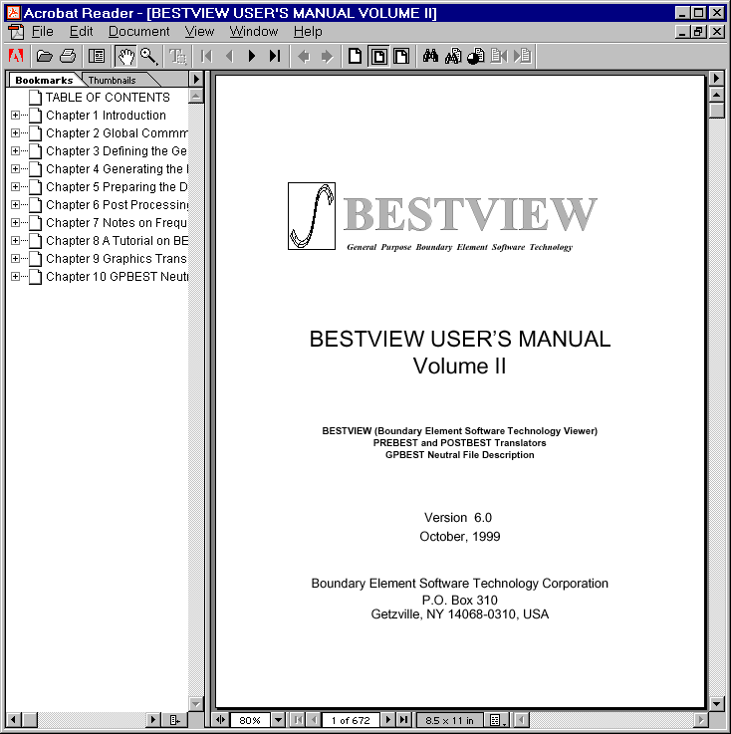

4 GPBEST Information Sources

The following sections instruct the user on where to get help and what sources of information are available for the GPBEST, GPBEST-DCE, BESTVIEW and TRANSLATOR system. This system was designed to give the user quick access to the information needed in developing complex engineering analyses for the GPBEST system.

4.1 Corporate Web Site

VISIT OUR CORPORATE WEB SITE:

Boundary Element Software Technology Corporation at http://www.gpbest.com

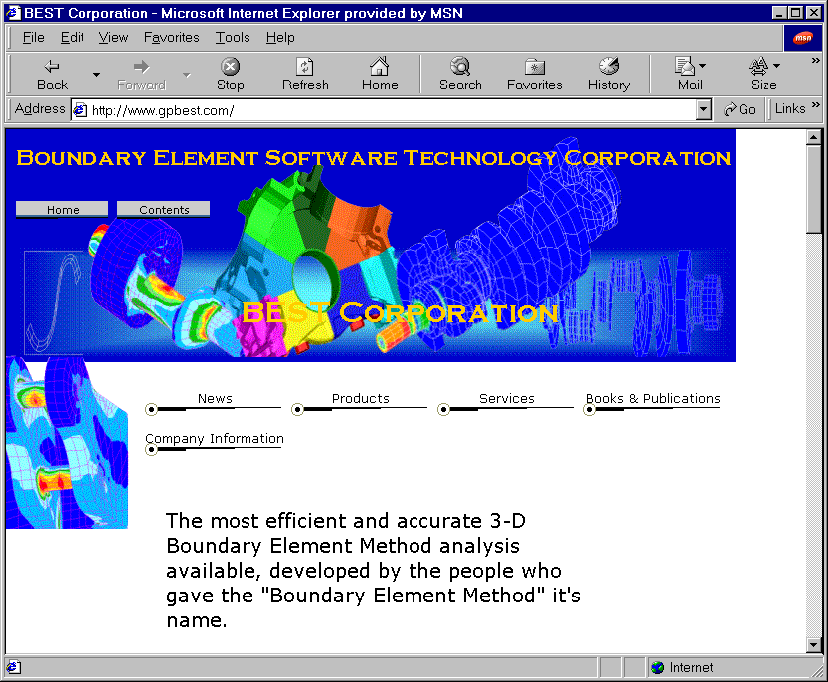

4.2 GPBEST Hard Copy Manuals

By default, all current GPBEST users receive both hard copy and on-line user manuals. Evaluation copies will receive only on-line user manuals unless hard copy manuals are purchased separately. The GPBEST manual titles and a short description of contents include:

- GPBEST USER’S MANUAL Volume I Version 6.0 October 1999
  - The GPBEST core module description
    - Introduction
    - Theory
    - Numerical Implementation
    - Guide to GPBEST
  - The GPBEST core module input
    - Case Control
    - Material
    - Geometry
    - Interfaces
    - Boundary Conditions
    - Body Forces
    - B.C. Changes
    - GPBEST-DCE
  - The GPBEST core module applications
    - Tutorial & Examples
    - Applications
    - Distributed Computing (DCE)
    - References

- BESTVIEW USER’S MANUAL Volume II Version 6.0 October 1999
  - The BESTVIEW core module description and input
    - Introduction
    - Global Commands
    - Geometry Definitions
    - Mesh Generation
    - Data Preparation
    - Post-Processing
  - The BESTVIEW core module applications
    - Frequently Used Features
    - Tutorials
  - The GPBEST core module graphics translators
  - The GPBEST core module neutral file description

- INTRODUCTION TO GPBEST: ELASTIC ANALYSIS Version 6.0 October 1999
  - Introducing the GPBEST System
  - Installation
  - Tutorial #1: Running an Example Problem
    - BESTVIEW Model
    - PATRAN Model
    - I-DEAS Model
    - HYPERMESH Model
    - FEMAP Model
  - Tutorial #2: 2-D Problem
    - BESTVIEW Model
    - PATRAN Model
    - I-DEAS Model
    - HYPERMESH Model
    - FEMAP Model
  - Tutorial #3: 3-D Problem
    - BESTVIEW Model
    - PATRAN Model
    - I-DEAS Model
    - HYPERMESH Model
    - FEMAP Model
  - Additional Helpful Information
  - References
  - Units and Dimensions
  - Useful Unix Scripts
  - GPBEST/BESTVIEW Password Request
  - GPBEST Elastic Analysis Keywords

4.3 GPBEST On-line Manuals

All of the GPBEST hard copy manuals are available on-line and are text-searchable. Also, extensive bookmarks and keyword hyperlinking are applied to each manual to aid the user in finding and navigating through the GPBEST documentation. Please refer to Section 1.2 Version 6.0 Documentation and Online Manuals for further information.

